APPLICATION FOR
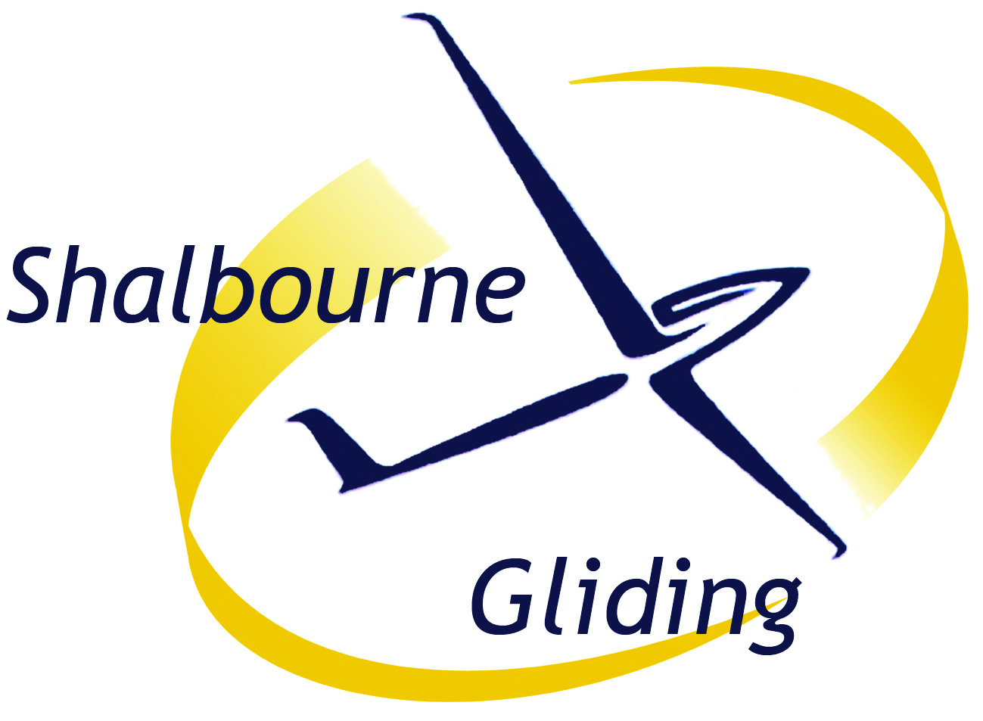
TEMPORARY MEMBERSHIP
AS A GUEST OF A FULL SGC MEMBER
“Friends and Family”
We are very pleased to welcome you to Shalbourne Gliding Club for one day, as invited guest of (who is a Full member)
…………………………..

This form creates legally binding obligations between you and the Club.
You should read it carefully before signing it.

I hereby apply for temporary membership of Shalbourne Gliding Club, permitting me to fly in the capacity determined by the Duty Instructor. I understand that the following data will be kept and used for club purposes only, e.g. so that I am kept informed about club news and events. [More information about how we treat your personal information is set out in the Club’s Data Protection Policy.]
Name: | Title Forenames (block letters please) Surname
Address
(inc Postcode):
Age as of today:
Contact Telephone:
Email:
I understand that this data will be kept and used for club purposes only.

[The Mandatory Safety Rules and Medical Notes are available in the Launch Point vehicle.
If you have not been given a copy, please request the notes now.]
I HAVE READ AND UNDERSTOOD THE MANDATORY SAFETY AND MEDICAL NOTES. I agree to follow the guidance provided to me, and to inform any friends & family who come with me to do the same. I undertake to follow any instructions given to me by Instructors, my sponsoring member and other members of the club.
I will bring to the attention of the Duty Instructor, in confidence, any medical condition which might cause an adverse effect during a flight. I am also aware that it is my personal responsibility to ensure that if there is doubt about my fitness to fly, I will not fly and will seek advice from my GP.
Signature of applicant:
Date

Signature of member:
Shalbourne Soaring Society Ltd – a company limited by guarantee.
Registered Office: Wessex Place, 127 High St, Hungerford, Berks RG17 0DL
Registered in England no.: 3471588

Temporary members (guest) form 2024 Pink Master copy held by Martin Selby

Emergency Contact Details
Please write in details of the person(s) who should be contacted in event of an incident/accident. Please asterisk your next of kin. Please supply sufficient details for us to be able to contact them in the event of an emergency. Please note that you will need to ensure we are kept informed of any changes to these details.
Name Relationship Telephone

GUEST of Member : “Friends and Family”
Direct members of Shalbourne Gliding Club (not SUGC members) may “sign-in” a friend or family member for one-day’s membership at a cost of £10 (as at June 2023). It is left to the member’s “sense of fair play” as to who they consider a friend and how far family extends and how often they bring someone.

The cost of flying is charged at full member rates regardless of the age of the guest.

The cost, including the day membership fee, is billed to the member’s account.

Friends & family guests, need to fill in the Guest Temporary Membership form, take their place on the flying list just as any full member, and fly depending on availability of an instructor and a 2-seater glider. Fixed time is not bookable as per the TL system.

There is no limit to either the number of flights on the day nor duration, other than limits dictated by demand on the day for instructors’ time and gliders etc.

F&F excludes: a) One month’s trial membership as bundled with a T.L. ………excludes b) Free third launch (This only applies to pre-solo full members)

