MEMBERSHIP FORMS

Rule 1A:
Everyone who flies needs to be a member of Shalbourne GC / SUGC

Full (Permanent) Members are listed on the sheet on the LPV Desk.

Southampton University Gliding Club is affiliated to SGC, so SUGC members are also on the LPV sheet. SUGC manage their membership list but keep me informed.
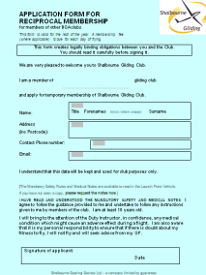
Reciprocal members are also on the sheet on the LPV Desk. Members of PNCC (Middle Wallop) and other BGA gliding clubs should fill in a Reciprocal Members Form which is in the rack. R. M. forms need to be renewed annually.
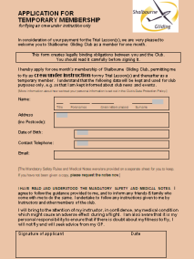

Trial Lesson Temporary Members are listed on the LPV sheet showing the 1 month cut-off dates. I am happy for others to add new TL members to this list as they occur. I will also check.

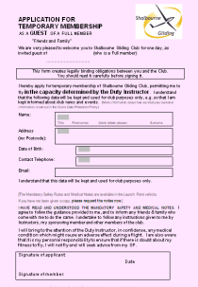
Friends and family: The member should fill in a Guest Membership Form which is in the rack at the back.

Wishing to jon as a Full (Permanent) member? Please fill in a TM form for today. Please indicate on the TM form that you intend to join as a Full (Permanent) member. I will follow up with membership form by e-mail and start the induction process for them. The contact details on the TM form need to be legible otherwise I can’t follow up!

If in doubt fill in a Temporary Membership form, as the default form.
At the end of the day, please put forms in the black tin to safeguard private data.

FLIGHT TRAINING PROGRESS CARDS are in the LPV filing cabinet.
Log books: please phone ring me 07989 494 148.

Management reserves the right to change the colour of theses forms without notice !!

Martin Selby 07989 494 148 27 June 2023

