APPLICATION FORM FOR
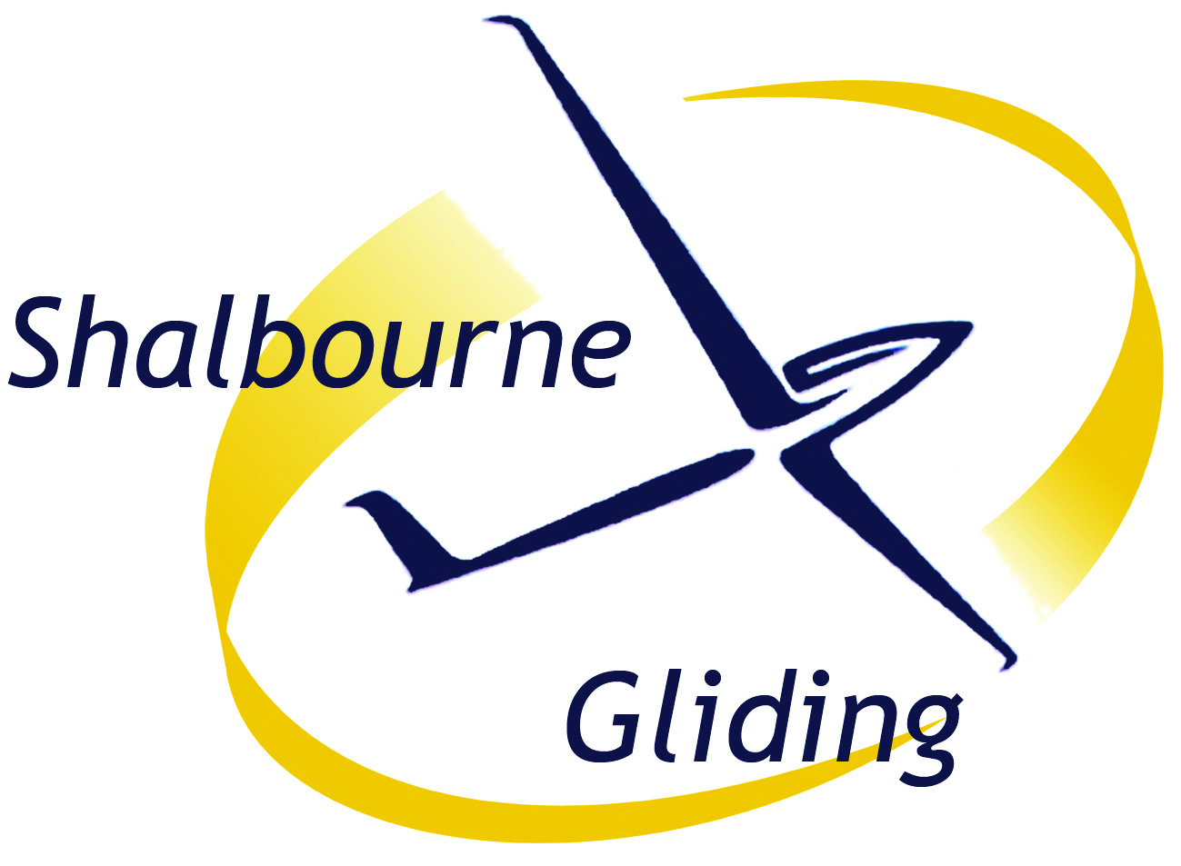
RECIPROCAL MEMBERSHIP
for members of other BGA clubs
This form is valid for the rest of the year. A membership fee
(where applicable) is due for each day of flying.
This form creates legally binding obligations between you and the Club.
You should read it carefully before signing it.

We are very pleased to welcome you to Shalbourne Gliding Club.

I am a member of gliding club
-----------------------------------------------
and apply for temporary membership of Shalbourne Gliding Club.
Name: | Title Forenames (block letters please) Surname
Address
(inc Postcode):
Age as of today:
Contact Phone number:
Email:
I understand that this data will be kept and used for club purposes only.

[The Mandatory Safety Rules and Medical Notes are available to read in the Launch Point Vehicle.
If you have not seen a copy, please request the notes now.]
I HAVE READ AND UNDERSTOOD THE MANDATORY SAFETY AND MEDICAL NOTES. I agree to follow the guidance provided to me and undertake to follow any instructions given to me by members of the club. I am at least 18 years old.
I will bring to the attention of the Duty Instructor, in confidence, any medical condition which might cause an adverse effect during a flight. I am also aware that it is my personal responsibility to ensure that if there is doubt about my fitness to fly, I will not fly and will seek advice from my GP.

Signature of applicant:
Date

Shalbourne Soaring Society Ltd – a company limited by guarantee.
Registered Office: Wessex Place, 127 High St, Hungerford, Berks RG17 0DL
Registered in England no.: 3471588
Reciprocal members form 2024 Blue Master copy held by Martin Selby
Emergency Contact Details
Please write in details of the person(s) who should be contacted in event of an incident/accident. Please asterisk your next of kin. Please supply sufficient details for us to be able to contact them in the event of an emergency. Please note that you will need to ensure we are kept informed of any changes to these details.

Name Relationship Telephone

RECIPROCAL MEMBERS – Land-outs
Every Reciprocal Member must fill in a Reciprocal Membership form and pay, or make arrangements to pay, the normal members’ Launch Fee before launching from Rivar airfield. Permission to launch reciprocal members is at D I discretion. Being winch-current will be a necessary criterion. ALL pilots must be approved to launch by THE DI beforehand.

SGC doesn't charge for landings; or charge a daily Reciprocal Membership fee for any pilot requiring a launch if they have landed out at Rivar Hill airfield.

