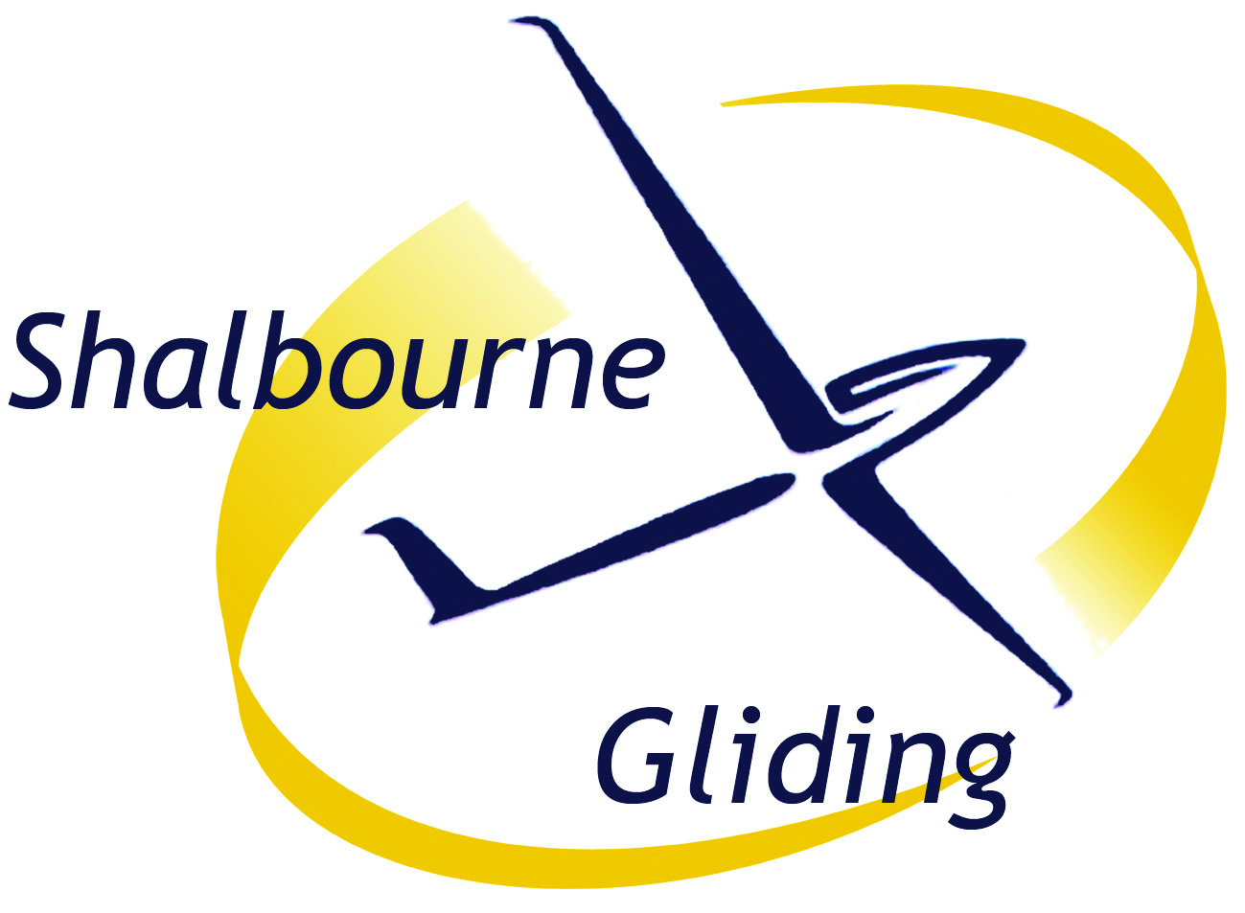
From November 2019
Flying Fees
Winch Launch - £9.00 (£7.00 juniors)
(Full members’ 3rd launch on a day free)
Club Gliders – 35p/min (27p juniors)
Introductory offer - £750 for
12 months launches and minutes
(for new, pre-solo members only)
Instruction is free
Full Membership (One Year)
£335 (£280 discounted, £385 family, £65 junior)
Trial Lessons
Intended for those who wish to try the sport.
£45 includes briefing and one flight of approx
15min if possible. Extra 15min or 2nd flight £35.
Pre-booked or voucher £80 for 30min or 2 flights.
If join club, fees recalculated as member,
excess credited to membership fee
Reciprocal Membership (One Day)
For Visiting Members of other Gliding Clubs.
£5, but no charge if visitor’s home club would
not charge Shalbourne members visiting them.
Member's Guest (One Day)
£6 (Charged to a/c of host Full Member)
Shalbourne Gliding is a Community Amateur Sports Club. Anyone who has genuine difficulty paying the standard fees above should contact the Treasurer to discuss low-cost options.
Enquiries to
treasurer@shalbournegliding.co.uk
tel. 01488 504966
From November 2019
Flying Fees
Winch Launch - £9.00 (£7.00 juniors)
(Full members’ 3rd launch on a day free)
Club Gliders – 35p/min (27p juniors)
Introductory offer - £750 for
12 months launches and minutes
(for new, pre-solo members only)
Instruction is free
Full Membership (One Year)
£335 (£280 discounted, £385 family, £65 junior)
Trial Lessons
Intended for those who wish to try the sport.
£45 includes briefing and one flight of approx
15min if possible. Extra 15min or 2nd flight £35.
Pre-booked or voucher £80 for 30min or 2 flights.
If join club, fees recalculated as member,
excess credited to membership fee
Reciprocal Membership (One Day)
For Visiting Members of other Gliding Clubs.
£5, but no charge if visitor’s home club would
not charge Shalbourne members visiting them.
Member's Guest (One Day)
£6 (Charged to a/c of host Full Member)
Shalbourne Gliding is a Community Amateur Sports Club. Anyone who has genuine difficulty paying the standard fees above should contact the Treasurer to discuss low-cost options.
Enquiries to
treasurer@shalbournegliding.co.uk
tel. 01488 504966
From November 2019
Flying Fees
Winch Launch - £9.00 (£7.00 juniors)
(Full members’ 3rd launch on a day free)
Club Gliders – 35p/min (27p juniors)
Introductory offer - £750 for
12 months launches and minutes
(for new, pre-solo members only)
Instruction is free
Full Membership (One Year)
£335 (£280 discounted, £385 family, £65 junior)
Trial Lessons
Intended for those who wish to try the sport.
£45 includes briefing and one flight of approx
15min if possible. Extra 15min or 2nd flight £35.
Pre-booked or voucher £80 for 30min or 2 flights.
If join club, fees recalculated as member,
excess credited to membership fee
Reciprocal Membership (One Day)
For Visiting Members of other Gliding Clubs.
£5, but no charge if visitor’s home club would
not charge Shalbourne members visiting them.
Member's Guest (One Day)
£6 (Charged to a/c of host Full Member)
Shalbourne Gliding is a Community Amateur Sports Club. Anyone who has genuine difficulty paying the standard fees above should contact the Treasurer to discuss low-cost options.
Enquiries to
treasurer@shalbournegliding.co.uk
tel. 01488 504966

